Oliver Rich
Your task:
In pairs you are to create a script for a new play called “Oliver Rich”.
In your script you must convey to your audience:
How has teenage life changed?
What is life like for teenagers now?
Why has these changes occurred?
What will life be like in the future for teenagers?

Information that may help
“Tesco is offering what it claims is the UK's cheapest digital set-top box. With a price tag of just £10, the Freeview box will certainly sound like a bargain to anyone who forked out over £100 to be in the first wave of Freeview box owners. Sitting next to it on the shelf could be Tesco's newly-launched £9 DVD player, while other supermarkets and the internet are offering equally knock-down prices for a range of electronic goods.” (BBC News, 2007)
How much have prices fallen over the last ten years?

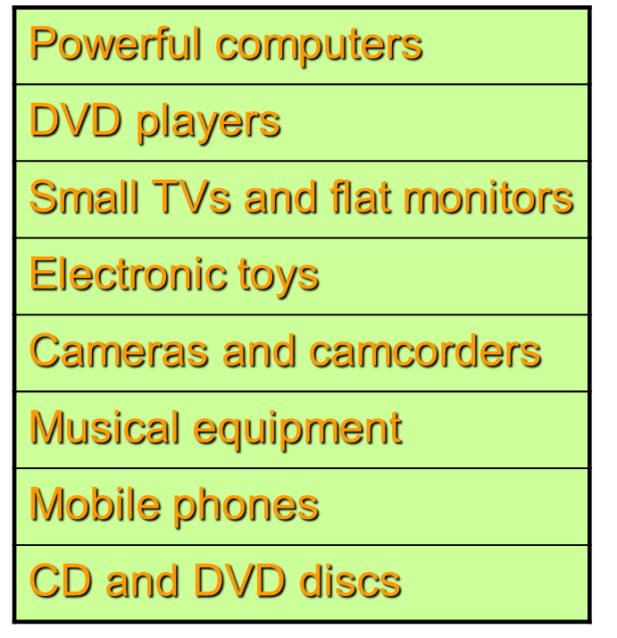
- 90% (£2,500 model now £250)
- 90% (£300 player now £30)
- 76% (£400 model now £100)
- 45% (£20 toy now £11)
- 40% (£300 camera now £180)
- 40% (£50 boogie-box now £30)
- 33% (£90 handset now £60)
- 50% (£16 disc now £8)

There are many reasons for falling prices, but one KEY FACTOR has been the falling costs of making electronic goods. In particular, the low wages paid to workers in China has led to factories being set up there that can produce goods more cheaply than in Europe. Much of what we buy is now imported from China – and is very cheap to buy. The lives of shoppers in the UK and factory workers in China have become inter-connected.

“A piece in The Times newspaper last year reported a decline in the number of burglaries, which was put down to the fact that the thieves can no longer get a good price for the items they steal. Who wants to nick a second hand DVD player, when you can buy a new, legal one for £20?” (BBC News, 2005)

