Food miles
Bananas  Country of origin: Costa Rica  Miles to the UK: 5957  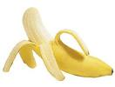 | Chocolate  Country of origin: Brazil  Miles to the UK: 5500  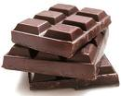
Tea  Country of origin: Kenya  Miles to the UK:4235 | Kiwi  Country of origin: New Zealand  Miles to the UK: 11364  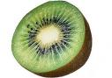
Steak  Country of origin: Scotland  Miles to the UK: 338  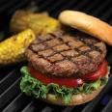 | Potatoes  Country of origin: Ireland  Miles to the UK: 327  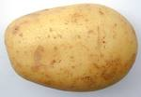
Snails  Country of origin: France  Miles to the UK: 432  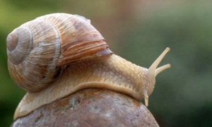 | Prawns  Country of origin: Bangladesh  Miles to the UK: 4989  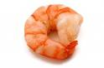
Rice  Country of origin: China  Miles to the UK: 5052  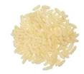 | Oranges  Country of origin: USA  Miles to the UK: 5396  